**Dr. ZAKIR HUSAIN COLLEGE, ILAYANGUDI**

**DEPARTMENT OF PHYSICS**

**DATA ANALYTICAL REPORT**

**ON**

**VISUALIZATION TOOL FOR ELECTRIC VEHICLE CHARGE AND RANGE ANALYSIS**

**Submitted By,**

**TEAM ID: NM2023TMID24647**

SHEIK DAWOOTH A (TEAM LEADER) – 0620122036

KAVIKKANNAN P - 0620122030

SIVAPRAKASH A B - 0620122038

GURUPRASATH N S - 0620122028

VARATHARAJAN K S - 0620122030

Faculty Incharge,

**Mr. P KALEEL AHAMED M.Sc., M.Phil.,**

ASSISTANT PROFESSOR,

DR. ZAKIR HUSAIN COLLEGE,

ILAYANGUDI.

1. INTRODUCTION

OVERVIEW & PURPOSE

The data analytics project visualization tool for electric vehicle charge and range analysis is a software tool designed to help users understand and analyze data related to the charging and range of electric vehicles. The purpose of this tool is to provide a visual representation of data that can help users make more informed decisions about electric vehicle charging and range management.

The tool can be used by a variety of stakeholders, including electric vehicle owners, fleet managers, and charging station operators. The tool can help these stakeholders to better understand how electric vehicles are being used, how much energy is being consumed during charging, and how far electric vehicles can travel on a single charge.

The tool typically integrates with data sources such as charging station logs, vehicle telematics data, and other sources of information related to electric vehicle usage. It then uses this data to create visualizations that allow users to explore and analyze trends and patterns related to electric vehicle charging and range.

Some of the key features of the tool might include interactive maps that show the location of charging stations, graphs that show charging patterns over time, and visualizations that allow users to explore the relationship between charging behavior and vehicle range. Ultimately, the goal of the tool is to help users make data-driven decisions that can improve the efficiency and effectiveness of electric vehicle charging and range management.

**2. PROBLEM DESIGNING & DESIGN THINKING**

**EMPATHY MAP**

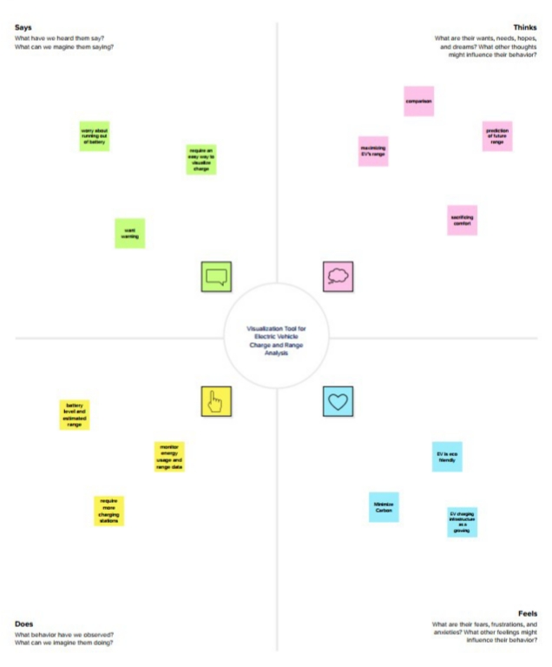

**BRAINSTORM AND IDEATION**

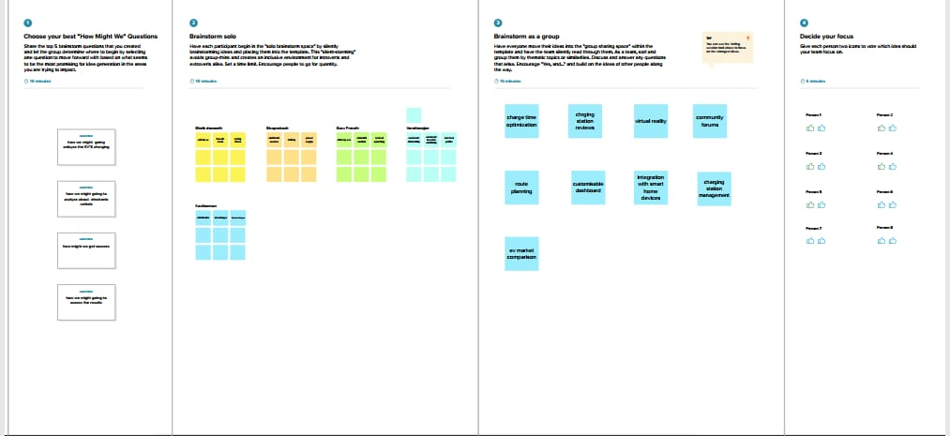

**3. RESULTS:**

**DASHBOARDS:**

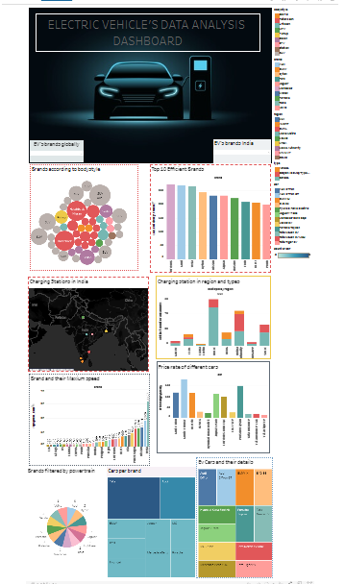

**STORY:**

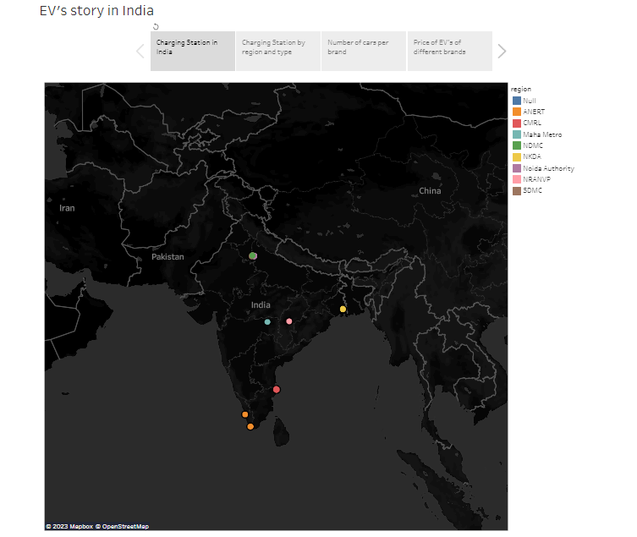

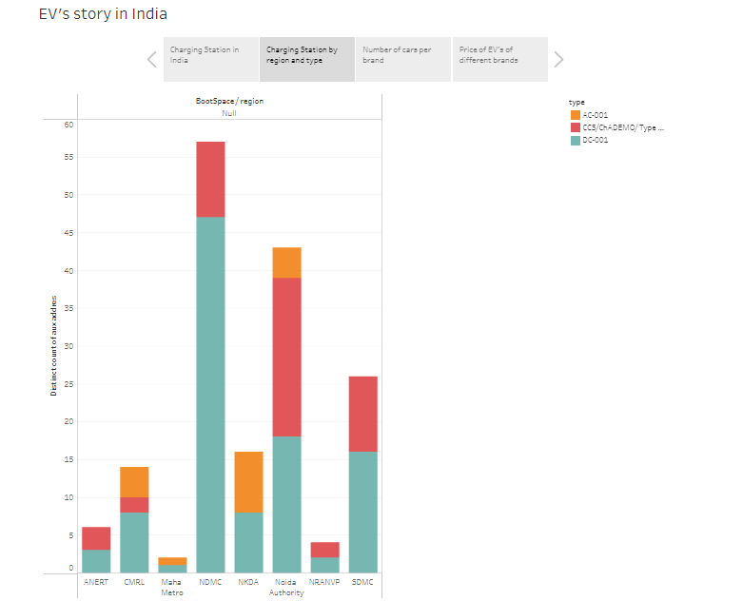

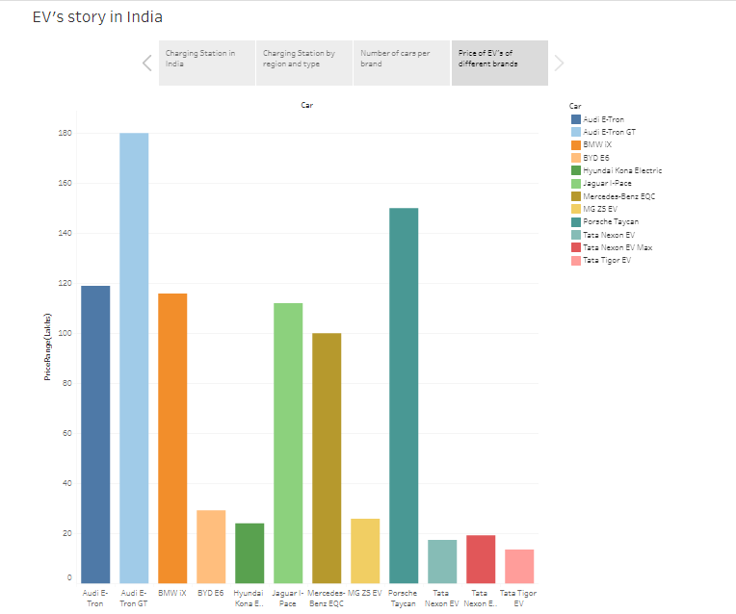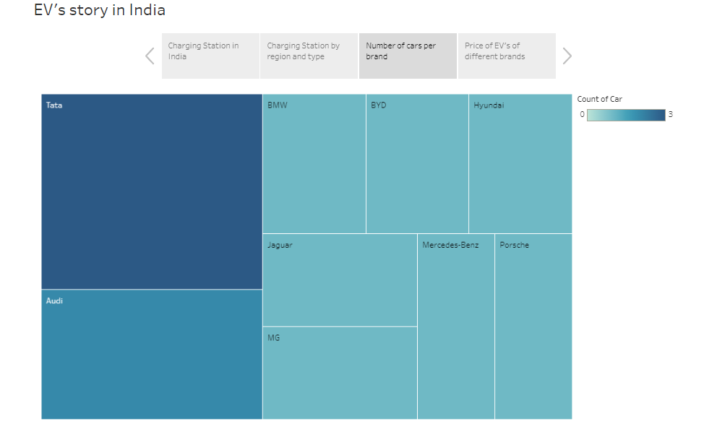

**4.ADVANTAGES & DISADVANTAGES**

**ADVANTAGES:**

**Improved decision-making:** The tool can help users make more informed decisions about electric vehicle charging and range management by providing insights into charging patterns and vehicle usage.

**Enhanced efficiency:** By analyzing charging patterns, the tool can help optimize charging processes and reduce downtime for electric vehicles, leading to more efficient use of resources.

**Increased transparency:** The tool can provide stakeholders with greater transparency into electric vehicle usage, charging patterns, and range, which can help to build trust and accountability.

**Improved planning:** The tool can assist in planning for the deployment of new charging stations by analyzing usage patterns and identifying areas of high demand.

**Reduced costs:** By optimizing charging patterns, the tool can help to reduce energy costs and improve the overall cost-effectiveness of electric vehicle use.

**DISADVANTAGES:**

**Data quality:** The accuracy and completeness of the data used in the analysis can impact the quality of the insights generated by the tool. Poor data quality can lead to inaccurate conclusions and flawed decision-making.

**Limited scope:** The tool may be limited in scope depending on the data sources available, which can impact the depth and breadth of the analysis.

**Complexity:** The tool may be complex and require specialized knowledge to use, which could limit its accessibility to some users.

**Cost:** The cost of implementing and using the tool may be high, which could be a barrier to adoption for some organizations.

**Security and privacy concerns:** The tool may be handling sensitive data related to electric vehicle usage, which could raise security and privacy concerns if not properly addressed.

**4. APPLICATIONS:**

The data analytics project visualization tool for electric vehicle charge and range analysis can have several applications in the electric vehicle industry. Some of the key applications include:

**Electric vehicle fleet management:** The tool can be used by fleet managers to monitor the usage and charging patterns of electric vehicles in their fleet, optimize charging schedules, and reduce downtime.

**Charging station operators:** The tool can assist charging station operators in understanding the usage patterns of their charging stations, identifying areas of high demand, and planning for the deployment of new charging infrastructure.

**Electric vehicle manufacturers:** The tool can provide electric vehicle manufacturers with insights into how their vehicles are being used, how much energy is being consumed during charging, and how far their vehicles can travel on a single charge.

**5. CONCLUSION:**

In conclusion, the data analytics project visualization tool for electric vehicle charge and range analysis can provide valuable insights into electric vehicle usage patterns, charging behaviors, and range management. The tool can help stakeholders make data-driven decisions to optimize charging schedules, reduce energy consumption, and improve the overall efficiency of electric vehicle use.

**6. FUTURE WORK:**

Future work for the project could include:

**Integration with other data sources:** The tool could be expanded to include data from other sources such as weather patterns, traffic data, and other environmental factors that may impact electric vehicle usage.

**Machine learning algorithms:** Machine learning algorithms could be integrated into the tool to improve the accuracy of the insights generated and enable more sophisticated analysis.

**User interface improvements:** The user interface could be further improved to make the tool more accessible to a wider range of users and increase its ease of use.

**Integration with other electric vehicle technologies:** The tool could be integrated with other electric vehicle technologies such as vehicle-to-grid systems and vehicle-to-building systems to provide a more comprehensive analysis of electric vehicle usage patterns.

**7.APPENDIX:**

**SOURCE CODE:**





